Learning Activity 2

Instructions
This learning activity is a bit of a review of a topic from the first module.
STEP 1: Examine the cartoon below and discuss its possible meaning using one of the sociological theories discussed in chapter 1 of SOCIOLOGICAL WISDOM.
STEP 2: Write a brief essay of 300-500 words that considers the following:
1. Identify which sociological theory best explains the social relationships and interactions highlighted in the cartoon.
2. How does this theory explain what is going on in the cartoon?
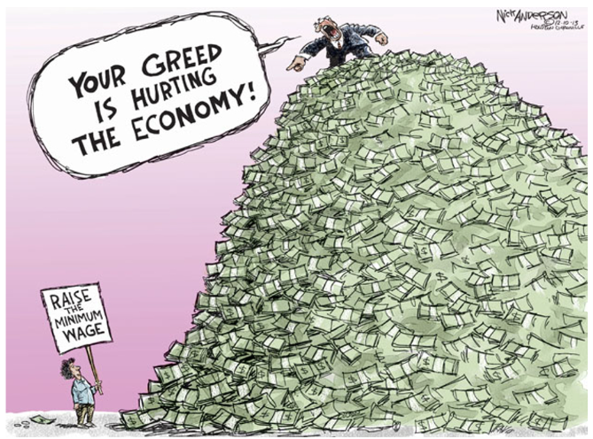

Response
The cartoon depicts a man in a suit standing on a pile of money, which clearly symbolizes the top 1% of ultra-high wealth earners. From his mountain of money, he is yelling, “Your greed is hurting the economy!” down to a simply dressed person holding a sign saying, “Raise the minimum wage”, who’s wealth is equivalent to pocket change. This is clearly an example of conflict theory because it is depicting the unequal distribution of resources (specifically money) between the ultra-wealthy and the working class. It is highlighting the fact that the extremely wealthy, who control most of the economy, are reluctant to pay a fair livable wage to their workers because it takes money away from their bottom line. It is clearly meant to invoke an emotional response by highlighting the ridiculousness of a man who is obviously greedy and hoarding wealth, calling an individual who is trying to make ends meet “greedy” for wanting a fair livable wage. So where does the true greed lie? On the one hand, this picture shows a single person asking for a raise from a single wealthy person, so it appears that what they are asking for is reasonable and should have very little impact on the wealthy person’s bottom line. The wealthy person shouldn’t have a problem doing that for him because he has wealth to spare, but instead he calls him greedy for even asking. But I’m sure that is not the only person working for him that thinks and feels that way. I’m sure that there is a long line of people asking for the same thing just outside of the frame of this picture, which plays into the slippery slope idea where if you do something for one, then you have to do it for all making the impact worse than you initially thought. Raising minimum wage would increase pay for everyone working for the wealthy person, which would have more of an impact on their bottom line. So to protect their bottom line, the wealthy person is trying to convince everyone them that this person’s request is unreasonable and anyone asking for the same is greedy. It reminds me of that “A Bug’s Life” clip where Hopper explains to the other grasshoppers that it may not be a big deal for just one ant to stand up to them, but that one ant is able to influence other ants to stand up to them (link to clip). I kind of see this political cartoon as the one ant trying to influence the other ants to stand up for themselves.

