Learning Activity 10

Instructions
According to the demographic transition model, societies move through several distinct stages of population change:
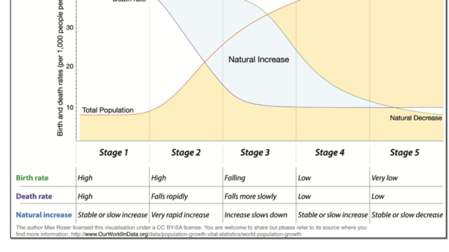
Image Description: The image above represents the stages of the demographic transition model. It consists of five stages: Stage 1 (high birth/high death), Stage 2 (high birth/declining death), Stage 3 (declining birth/declining death), Stage 4 (low birth/low death), and Stage 5 (declining population).
Now, please read this brief report from the Brookings Institute on birth rates in the United States: https://www.brookings.edu/blog/up-front/2021/05/24/will-births-in-the-us-rebound-probably-not/
Using these two sources of information, write a brief essay (200-300 words in length) that assesses which stage of the demographic transition the United States is currently going through. Why do you think birth rates have fallen below replacement level?

Response
I believe that the U.S. is in stage 4 (low birth/low death), possibly on the brink of stage 5 (declining population). I think there are multiple reasons for why this is happening, but the primary reason it has dropped so low is because of how poorly women are treated. Maternal leave policies in the U.S. are terrible because current laws only guarantee 12 weeks of unpaid leave. Most other countries have policies in place that guarantee they will receive at least a portion of their earnings during their time off, and they are granted a minimum of 14 weeks paid time off, with some countries offering as much as 58 weeks (World Population Review, 2026). I also feel like abortion bans have a lot to do with it as well. While live births may increase in states that have banned abortion, infant mortality rates also go up as a result of not having access to essential care (Johns Hopkins Bloomberg School of Public Health, 2025). I’ve seen a lot of stories about women living in states with abortion bans having to travel out of state to receive abortion care, and the hardships they had to deal with as a result. I’ve also seen stories of doctors in those same states being afraid to perform abortion care because they don’t want to be arrested. When you combine the lack of financial support and fears brought on by abortion bans with the removal or reduction of funding for programs like WIC, SNAP, and Medicare meant to help provide food and medical care; it becomes too expensive and risky to have and raise a child. Taking all of this into consideration, you end up with women who don’t really have much incentive to have children. In South Korea, women are choosing to not have children as a result of gender inequality and a lack of shared domestic responsibilities (Mackenzie, 2024), and I see that as a growing problem here in the U.S. as well.

References
Johns Hopkins Bloomberg School of Public Health. (2025, February 13). Two New Studies Provide Broadest Evidence to Date of Unequal Impacts of Abortion Bans. Retrieved from Johns Hopkins Bloomberg School of Public Health: https://publichealth.jhu.edu/2025/two-new-studies-provide-broadest-evidence-to-date-of-unequal-impacts-of-abortion-bans
Mackenzie, J. (2024, February 27). Why South Korean women aren't having babies. Retrieved from BBC: https://www.bbc.com/news/world-asia-68402139
World Population Review. (2026). Maternity Leave by Country 2026. Retrieved from World Population Review: https://worldpopulationreview.com/country-rankings/maternity-leave-by-country

